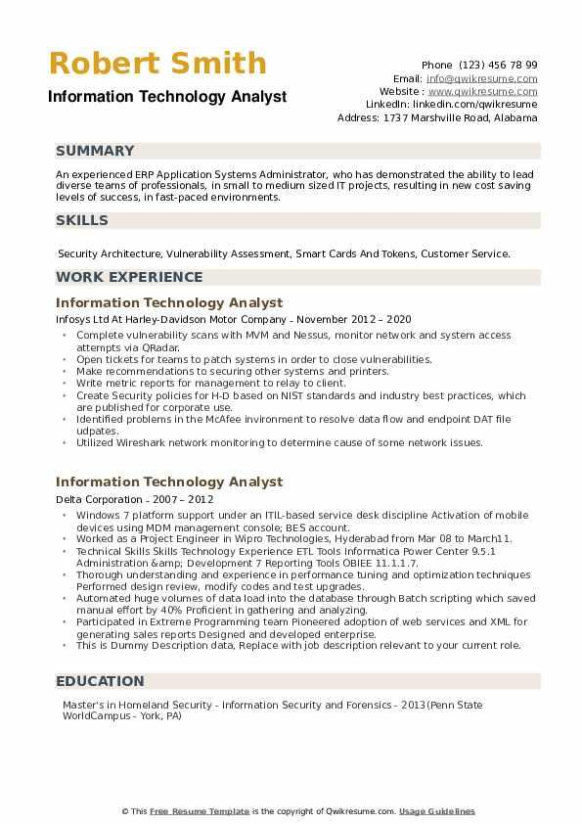
Robert Smith
Information Technology Analyst
SUMMARY
Phone (123) 456 78 99
Email: info@qwikresume.com Website: www.qwikresume.com Linkedin: linkedin.com/qwikresume Address: 1737 Marshville Road, Alabama
An experienced ERP Application Systems Administrator, who has demonstrated the ability to lead diverse teams of professionals, in small to medium sized IT projects, resulting in new cost saving levels of success, in fast-paced environments.
SKILLS
Security Architecture, Vulnerability Assessment, Smart Cards And Tokens, Customer Service. WORK EXPERIENCE
Information Technology Analyst
Infosys Ltd At Harley-Davidson Motor Company - November 2012-2020
• Complete vulnerability scans with MVM and Nessus, monitor network and system access attempts via QRadar.
• Open tickets for teams to patch systems in order to close vulnerabilities.
.
Make recommendations to securing other systems and printers.
⚫ Write metric reports for management to relay to client.
• Create Security policies for H-D based on NIST standards and industry best practices, which are published for corporate use.
⚫ Identified problems in the McAfee invironment to resolve data flow and endpoint DAT file udpates.
⚫ Utilized Wireshark network monitoring to determine cause of some network issues.
Information Technology Analyst
Delta Corporation - 2007-2012
• Windows 7 platform support under an ITIL-based service desk discipline Activation of mobile devices using MDM management console; BES account.
• Worked as a Project Engineer in Wipro Technologies, Hyderabad from Mar 08 to March11. ⚫Technical Skills Skills Technology Experience ETL Tools Informatica Power Center 9.5.1 Administration &amp; Development 7 Reporting Tools OBIEE 11.1.1.7.
⚫ Thorough understanding and experience in performance tuning and optimization techniques Performed design review, modify codes and test upgrades.
⚫Automated huge volumes of data load into the database through Batch scripting which saved manual effort by 40% Proficient in gathering and analyzing.
•Participated in Extreme Programming team Pioneered adoption of web services and XML for generating sales reports Designed and developed enterprise.
⚫This is Dummy Description data, Replace with job description relevant to your current role.
EDUCATION
Master's in Homeland Security - Information Security and Forensics- 2013(Penn State WorldCampus - York, PA)
This Free Resume Template is the copyright of Qwikresume.com. Usage Guidelines

